**A report on visiting liberation war museum**

Definition: A museum is an object of historical, scientific, artistic, or cultural interest are stored and exhibited .it is considered a house of knowledge. They offer a platform for researchers and scholars.

**Liberation war museum:**

The Liberation War Museum began under the initiative of an eight-person board of trustees as a means of preserving the memory of the 1971 [Liberation War](https://en.wikipedia.org/wiki/Bangladesh_Liberation_War). The trustees sought donations from the general public to fund the museum and for the general public to come forward with artifacts to be displayed artifacts from the war, including personal belongings, weapons and human remains, as well as creating an archive of documents and personal histories related to the war. Over the years the museum collected more than 21,000 artifacts (as of 2016), with some as exhibits on display in the museum and many more stored in its archives. The museum describes itself as "the outcome of a citizens' effort"[[2]](https://en.wikipedia.org/wiki/Liberation_War_Museum#cite_note-2) due to the crowd-funded nature of the museum (which is independent of the Govt. of Bangladesh) and the collective contribution of the general public to the museum's collection.

**Relocation**

Due to a lack of space, it was only possible to display a fraction of the collected artifacts at the original premises, so it was decided that a bigger, more modern premises was required. In 2009, an architectural contest was held for the new design of the museum, with architects Tanzim Hasan Salim and Naheed Farzana winning the first prize for their designs. In 2013 land was acquired in Agargaon for the new building and construction began. The new premises of the Liberation War Museum were officially opened on 16 April 2017.[[3]](https://en.wikipedia.org/wiki/Liberation_War_Museum#cite_note-3) The new building provided much more space with 3500 square meters of gallery space.

Gallery

The coverage of the war continues to India's support for the Mukti Bahtini and its subsequent direct intervention with the outbreak of the [Indo-Pakistani War of 1971](https://en.wikipedia.org/wiki/Indo-Pakistani_War_of_1971), which led to the surrender of all Pakistani forces in Bangladesh on 16 December 1971.

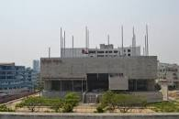

**How we achieved it:**

Bangladesh is an independent country. We achieved it through nine-month bloody war. And we achieve our own map, flag, and now we are a sovereign country. Our government established liberation war museum for the memory of our great freedom fighters.



***A memorable day on liberation war museum:***

Recently I visited the liberation war museum Dhaka it is situated at Agaragon.it was a part of our academic assessment. We enjoyed the day. We visited the aesthetic galleries, weapons shirt of our greatest freedom fighters. We captured so much pictures. A guide teacher showed us the sector map, our history, identity and liberation war related news. After visiting the museum, our honorable mam arranged a quiz competition for us. I obtained 3rd position and I achieved a book which is based on liberation war. afterwards, we took some pictureswith my friends.at the evening, I reached on my destination. The day was so memorable that still I cannot forget it.

**Remarkable objects that I visited:**

**Radio: Radio plays a** vital role during liberation war.it broadcast the valuable news irrespective of freedom fighters and all type of general people. Akash bani was. the remarkable radio channel.

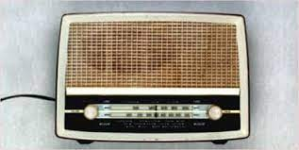

Sector map:

Bangladesh was divided into 11 sectors during liberation war. Three sector commanders were to conduct the all sectors. they are respectively Major Khaled Mossaraf Hossain, Major Ziaur Rahman, Major KM Shafiullah.

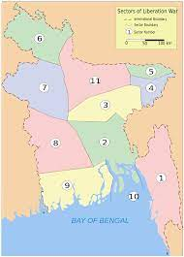

The independent map

Weapons: our heroic freedom fighters took away freedom for us through these weapons.

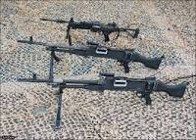

***Allocated budget for liberation war ministry:***

*Why should students visit museum:*

* Museums are cultural and educational institutions where children can learn about diverse cultures, fresh ideas, and distinct creative works. They’re also entertaining and ever-changing. Curators are aware of this, yet many visitors are unaware.
* Museums preserve and exhibit important cultural, artistic, historical or scientific artifacts. While these exhibits provide informative and visual explorations, there are many benefits to visiting these institutions. Simply put, museums help to teach, inspire and connect communities.
* They provide spaces for social interaction and reflection. And they make valuable contributions to their local communities.

***Conclusion:***

A museum contains a heritage, and history of a sovereign country. We should visit it and our government should preserve it for our next generation so that they can learn our enriched history. We got our museum through sacrificing our freedom fighters’ lives. We can achieve knowledge by visiting museum.